**CS2821 Systems Programming**

C:

* No standard, unified interface
* Can use POSIX interface
* Predictable performance
  + No overhead from VM
  + Full control of memory
  + No GC in bg
* Access to low-level functionality
  + Full access to system API, priv
  + Arch/machine code
  + Access to all hardware
* Manual memory management
  + Errors lead to crashes/leaks
* Reduced portability
  + Needs to recompile for every platform
  + OS func not guaranteed to be avail

**Structured Control Flow**

* If, for, do-while, break, continue

**Unstructured control flow**

* Goto = JUMP
* Hard to uds
* (don’t use it, very few legit use)

**Types**

* Unsigned (java = all signed)
  + Larger positive (no negative)
  + 2s complement
  + Change interpretation of prgm   
    (no change in data)
* No Booleans (use integer)
  + 0 = F, 1(or anything) = T
* Char<=short<=int<=long<=long long

**When to use unsigned**

* Documents expected range of value
  + Colour values
* Wrap-around of signed integers   
  (not guaranteed)
* Modulus operator = well-defined
  + Odd/even might not work as expected with negative

**Operator evaluation**

* X = y= 5; works
* Int x = y = 5; not works

**Variable initialization**

* Int x; (x is initialized with anything, not 0)

Functions (declare on top)

Printing

* Puts, printf
* %d:demical, %f:floating point, %s:string

Input

* Gets = vuln
* Scanf(%d, num) = 0 = error
* Getline (allocates mem as required)

Array

* Int nums[10]
* No NEW (need heap)
* No .length attribute
* Array length not checked (buffer overflow)

Char/String

* String = 0-terminated arrays of char
* Use length+1 byte
* Char name[] = “RHUL”
  + 5 bytes (4 for each char, 1 for terminator)

String pointes

* Char * : pointer to a character
* Char *name = “RHUL”;

String functions

* Int Strcmp(s1, s2)
* Size_t Strlen(s)
* Char *Strcpy(s1, s2)
* Char *Strcat(s1, s2)
* String don’t grow automatically
  + Reserve large enough
* No safety checks

**Pointers**

* C= explicit pointers
* Declare = int *pointer
* Create = int var; pointer1 = &var; (& = addr of)
* Deref = *pointer = 5;

Pointers as PARAM

* Receives pointer = Variable can be modified

Parameter passing in C

* Pass the value
  + Int/float/struct = ok
  + Array = cannot
  + Function = own copy of data
    - Modification lost
* Pass pointer to value
  + Modification affects

Arrays

* Pointers and arrays = type-compatible
* Array var = pointer to first element
* DIFF
  + Array declaration = reserves space for ALL data
  + Point declaration = reserves space only for pointer, not data
* Pointer moves inside array pNum = pNum +1
  + pNum[1]

String (char array)

* char pointer = points to first character

**Memory** = seq of bytes

* very large array
* mem addr = array index
* pointers store address
* mem stores everything

**Endianness**

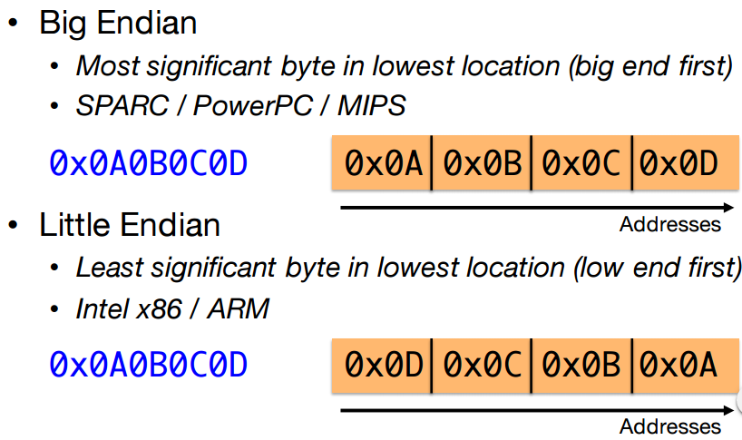

**Command Line**

**Command Line Arguments**

* int main (int argc, char* argv[])
* argc (no. of arguments)  
  argv ( array of strings)

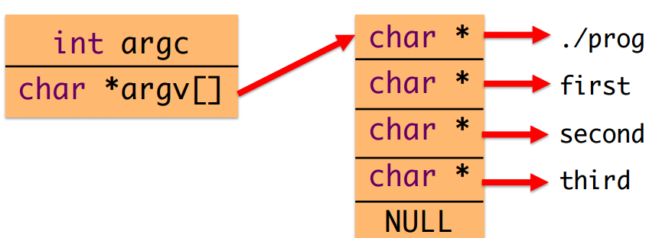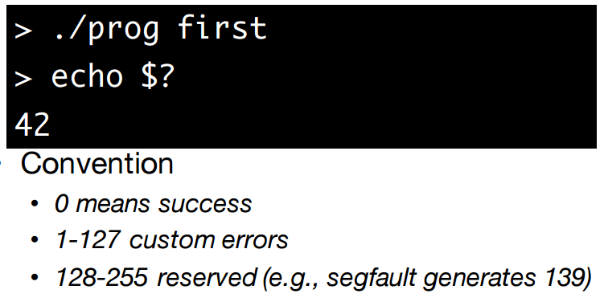

**Structures**

C = not object-oriented

* no classes, but good to group data

Struct = only data, no methods!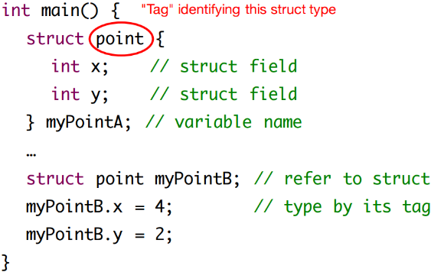

GLOBAL  
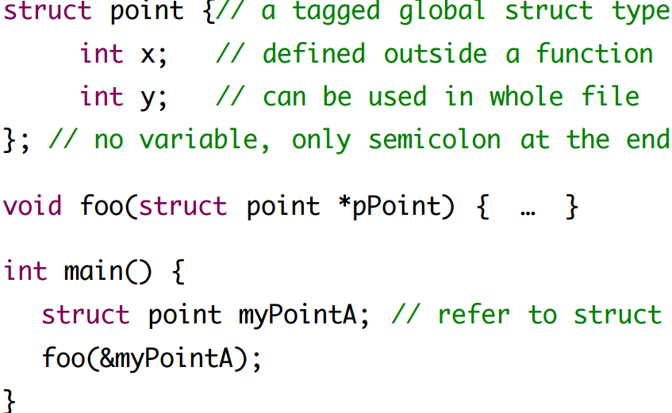

IF declared as string buffer in struct, need to user strcpy(john.firstname, “John”)

If declared as string pointers in struct, can use  
john.firstname = “John”;

**Pointers and structs**

Struct student *pStud;

pStud->id;

**TypeDef = shortcut (no need tags)**

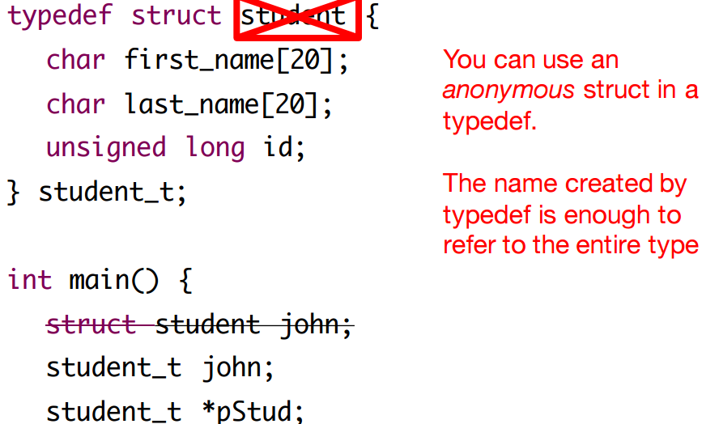

**Unions (seldom usage)**

Struct with overlapping members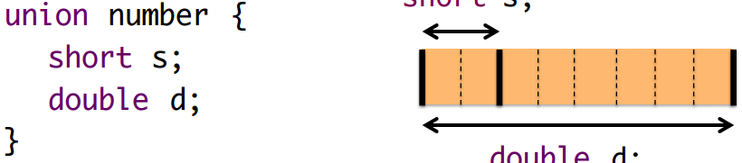

* used in protocols and API
* C’s version of polymorphism
* Convert parts of value (but dangerous)

**Dynamic Memory**

Unknown before running program.

**MALLOC =** memory on the heap

* Stdlib.h
* Returns pointer to new mem obj (void pt)
* Cast to required type (arrays, structs, primitive[not make sense])

Use malloc(8 * sizeof(int));

* to dynamically calculate size
* with or without parentheses
* evaluated at compile time, not runtime

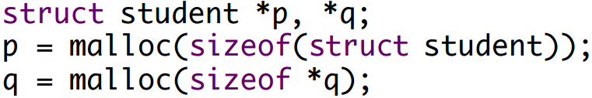

Calloc (0 initiailize it)

Realloc (change size)

* array grows too large, realloc and double size

Return NULL if fail

(check for NULL)

**Freeing Memory**

Void Free(void *ptr)

**Memory leak**

Allocated memory is no longer referenced

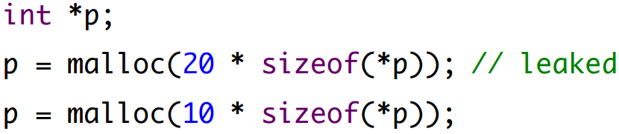

**Linked Lists**

Recursive data structure

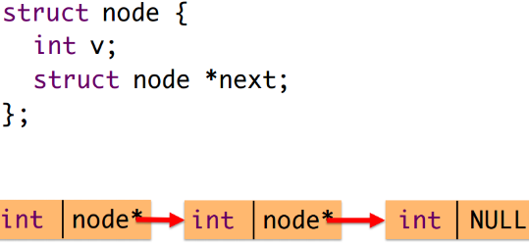

**Doubly Linked List**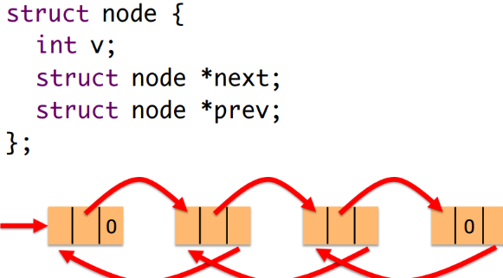

**Binary Tree**

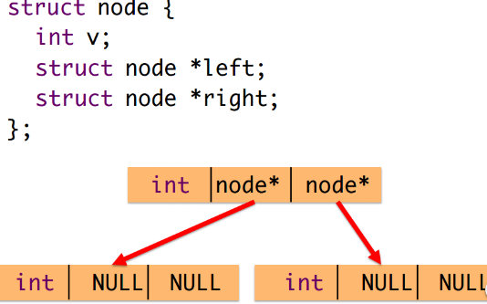

**Memory Organization**

Identifier Visibility

* block scope
* function scope
* file scope
  + use static
* program scope (global)

**Process Memory**(on top is OS)  
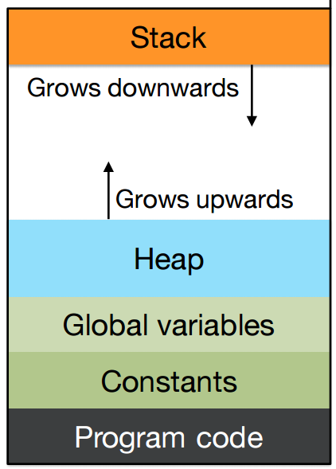

**Stack**

* LIFO
* Grows with func call
* Shrinks with func ret
* Local var, func arg, ret address

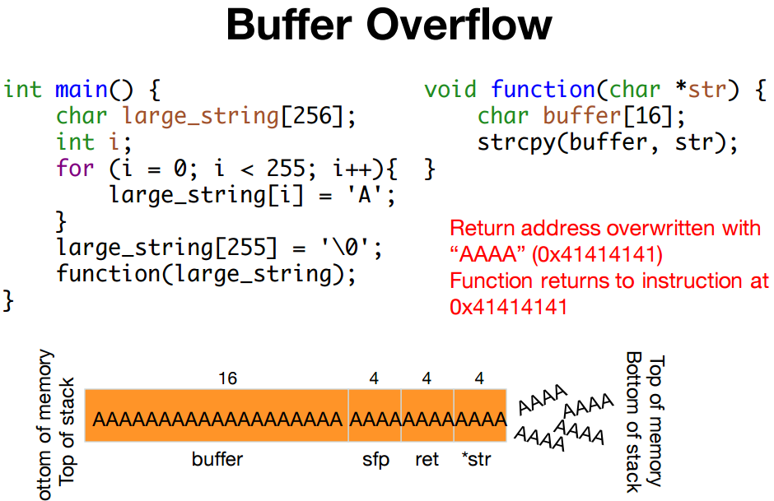

Malloc = allocates mem from Heap

**Freelist = doubly linked list**

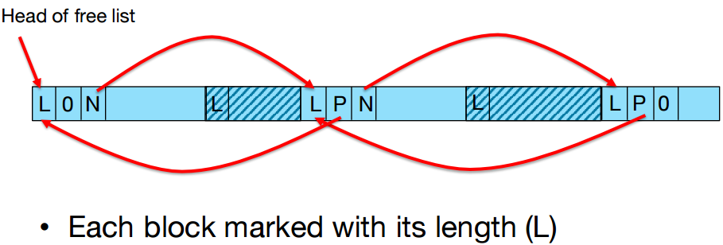

**Strategies**

* Optimize performance
* Bestfit, firstfit
* Larger blocks = fit
* Repeated small malloc = fragmented   
  (custom allocator)

No MEM = no free block, return NULL

Increase HEAP, cannot increase itself   
(usr space, so need system call)

* Calls mmap (tell OS that it needs more mem)
* Additional page in virtual pages

**Virtual Memory**

* Process = private space
* OS maintains page table
* Access unmapped area = seg fault

Address Allocation

* Exact addr = varies
* Increased by ASLR (randomization, nondetermistic)
* 64bit = 48 bit usable (256 TB usable)
* 32bit = 32 bit usable (4GB usable)

Print pointers ( %p)

**Copy Memory**

**Strcpy =** copies char until ‘\0’

Copy Array =  
 - loop, index by index  
 - func for low level mem

Memcpy = copy byte-to-byte (use void pt)

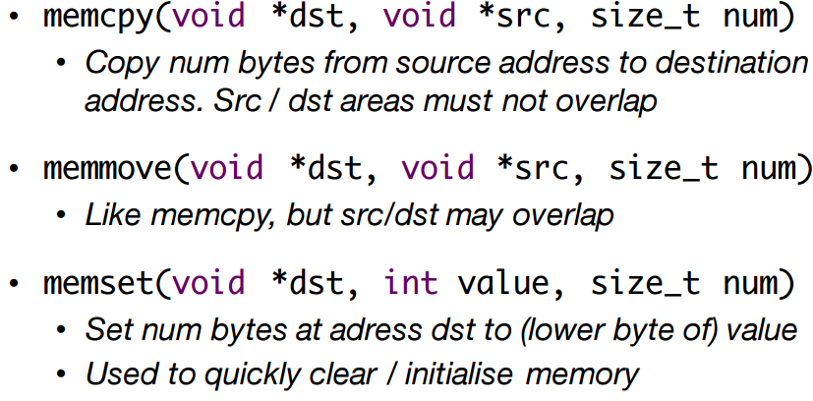

**Type Qualifiers**

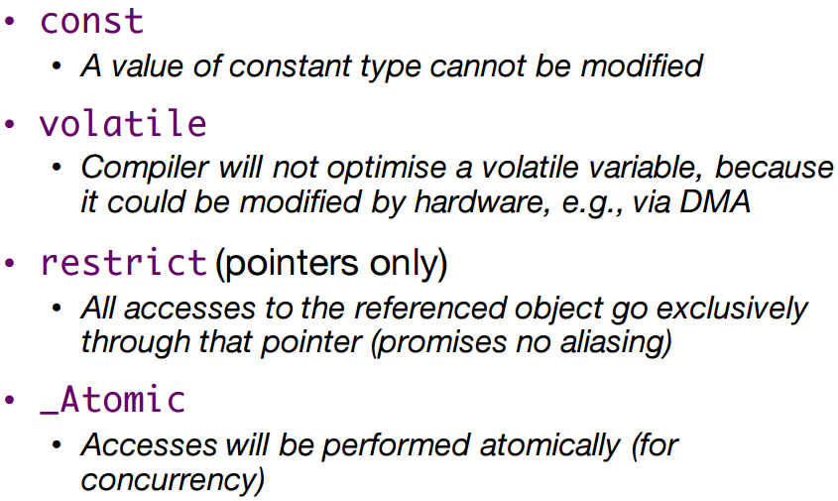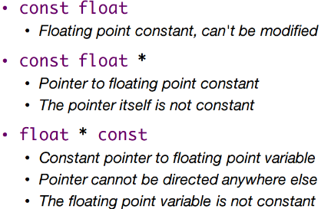

**Const enforcement**

* **Compile time**
  + Doesn’t allow direct write
* **Runtime**
  + May put into write-protected
  + Triggers “Access Violation”

**String Literals**

* “RHUL” = anonymous character sequence
* Store in mem, loaded from binary, RO

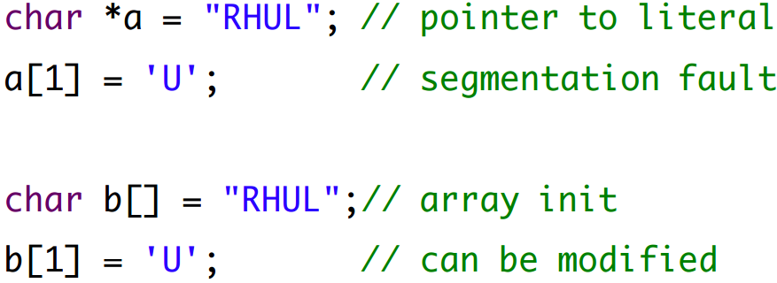

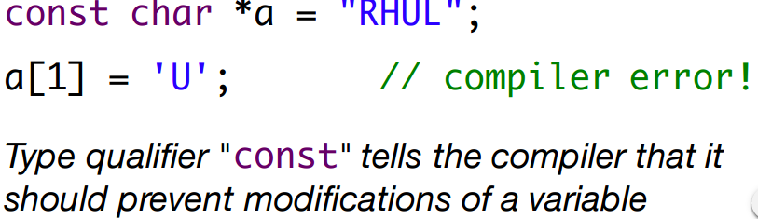

**Initialised String Buffer = char a[]**

* Allocates a buffer the size of the string literal
* Generates code to fill it in

**Assigning String**

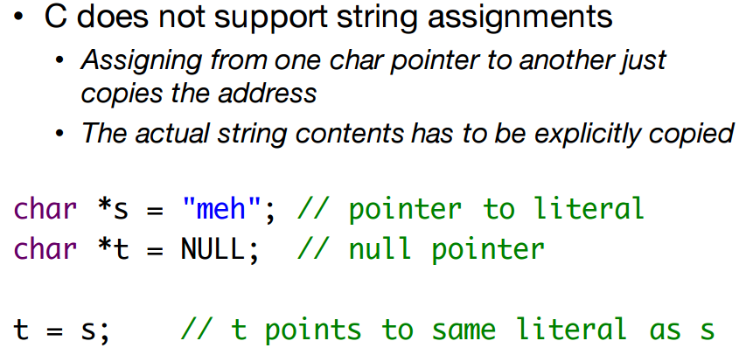

**Copying Strings**

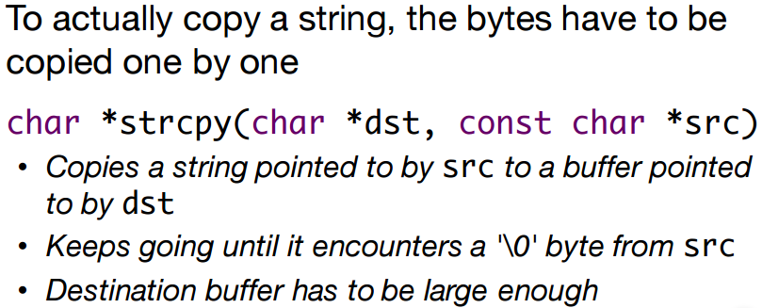

**Comparing Strings**

* **==** is comparing pointers
* Strcmp(a, b) to compare the string

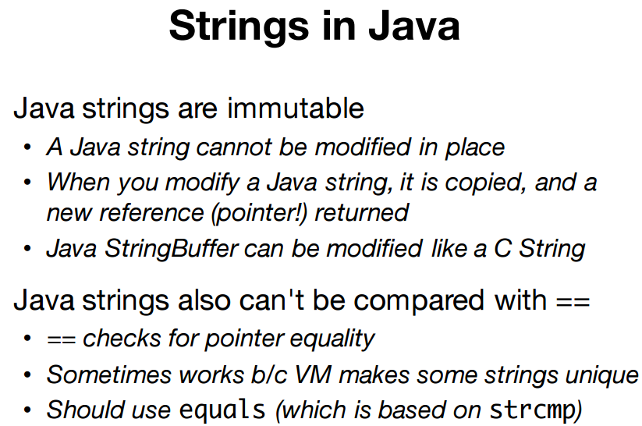

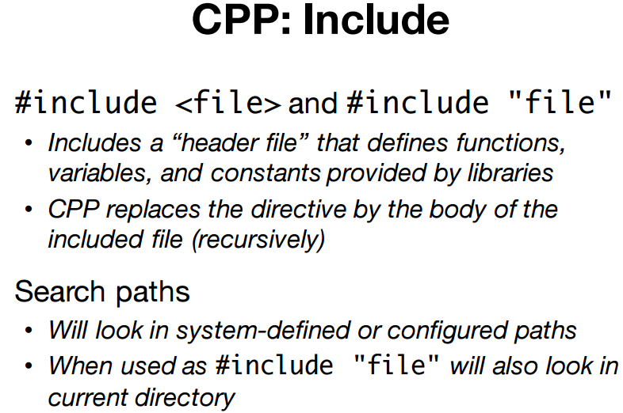

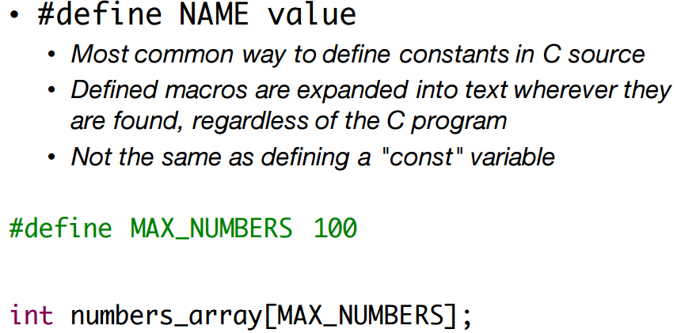

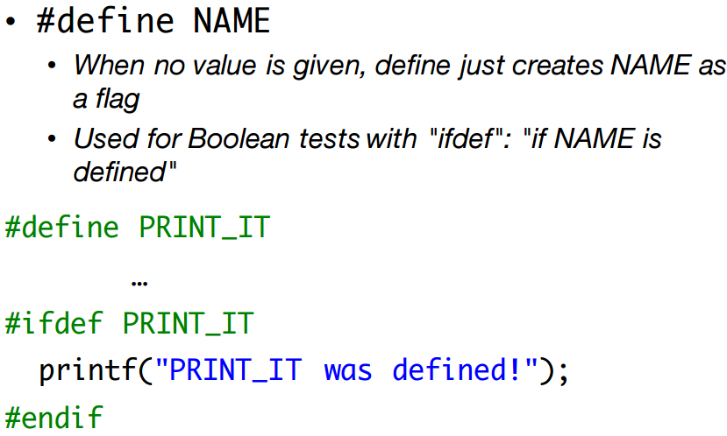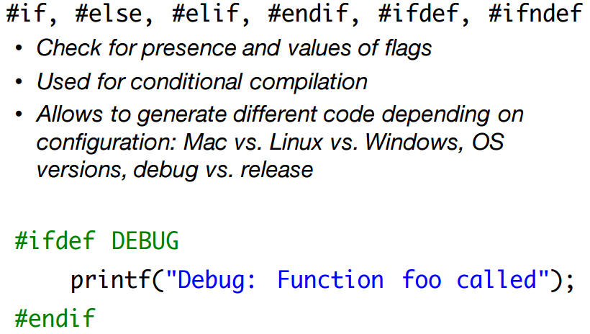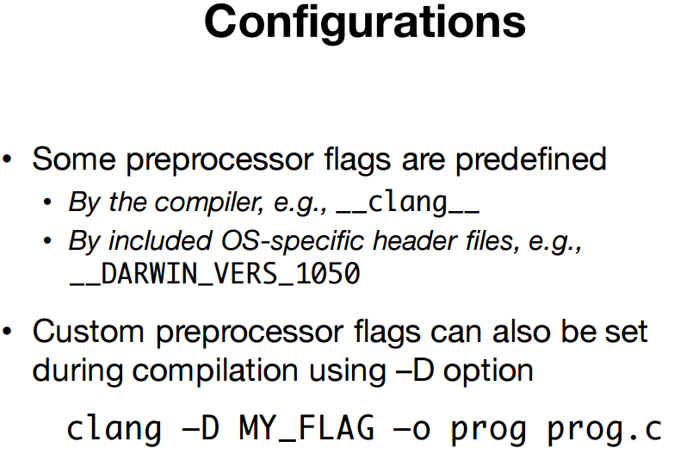

**Constants = CAPITAL**

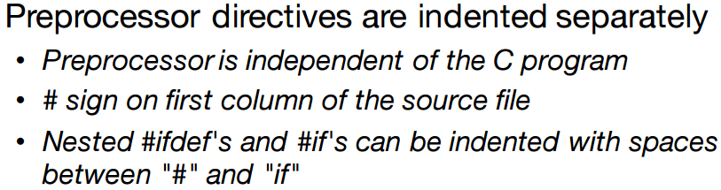**I/O**

* uses syscall (privileged ops)
  + hardware access (encap by OS)

**Via Direct Sys Call**

* unnecessary difficult
* not portable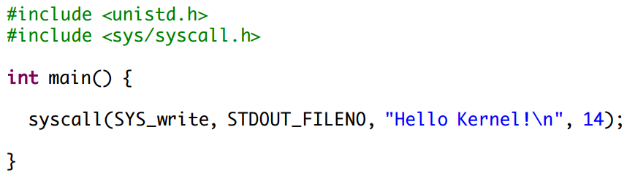

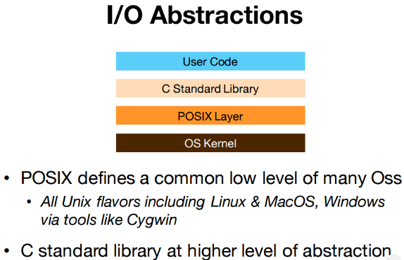

**Via POSIX**

* portable, not convenient

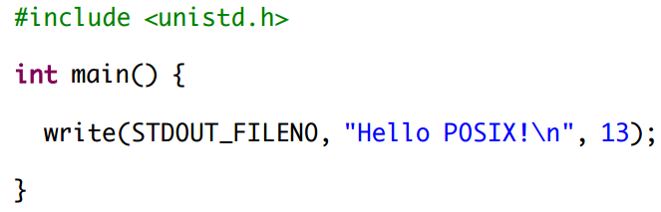

**Via LibC**

* portable and convenient

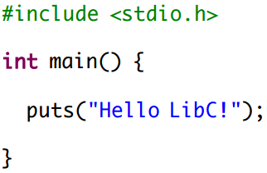

**C Standard Library**

* few keywords
* I/O, char, strings, time, etc
* Declared in standardized header files

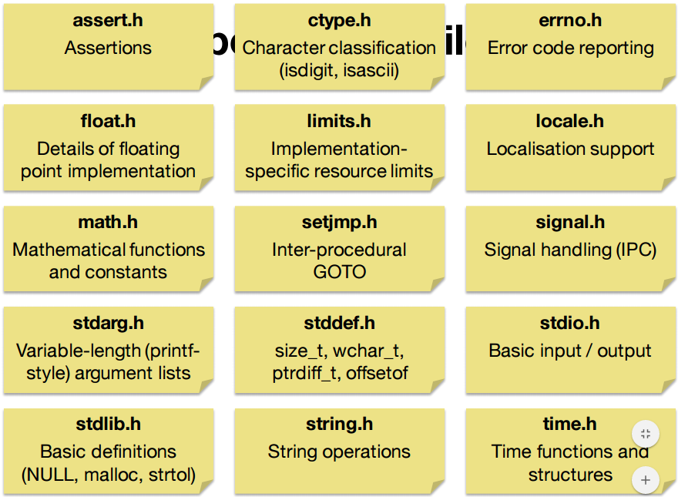

**File I/O**

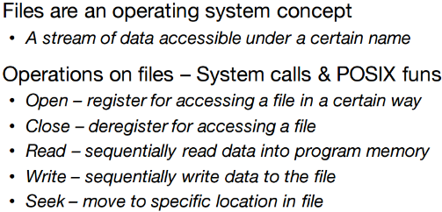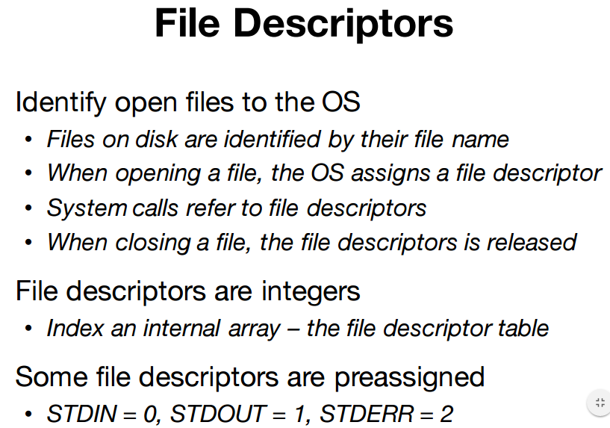

**FILE**

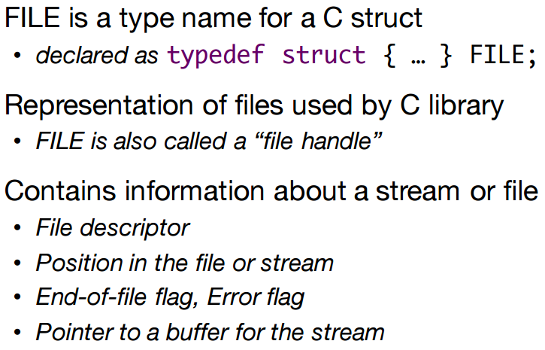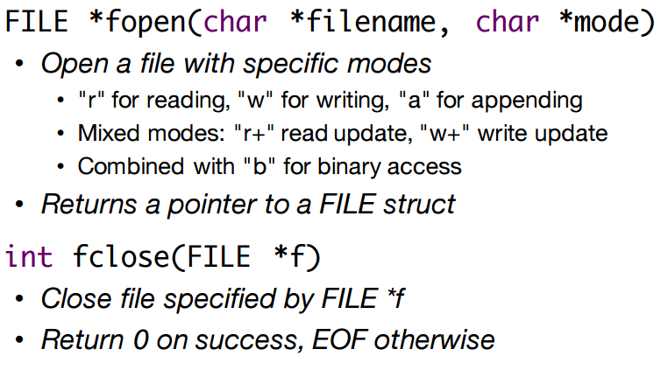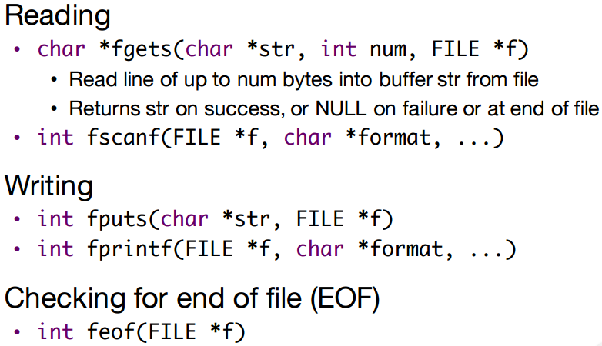

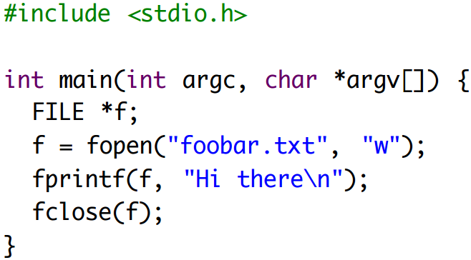

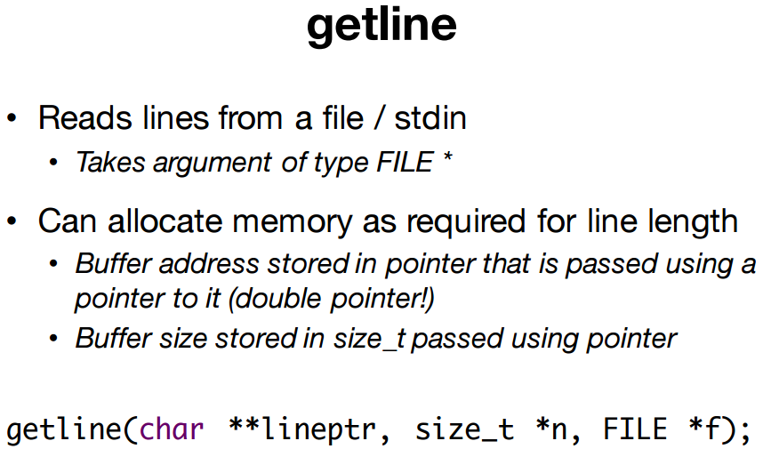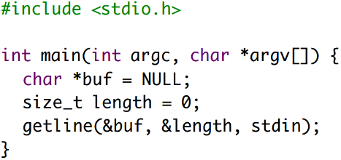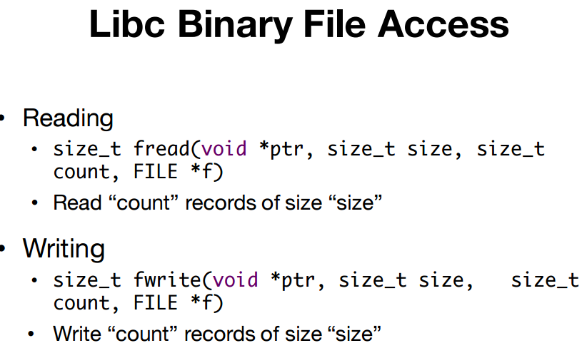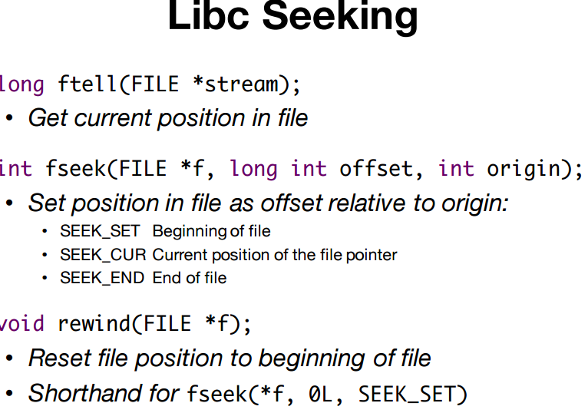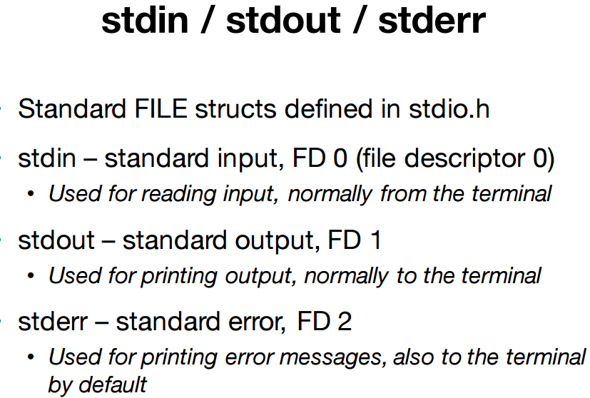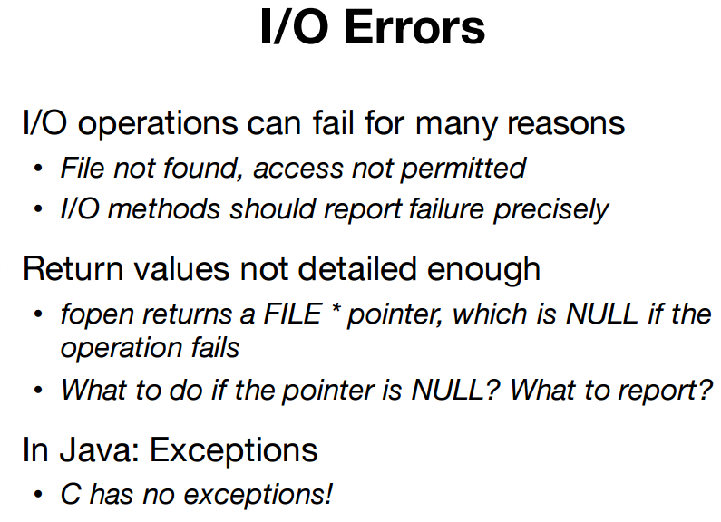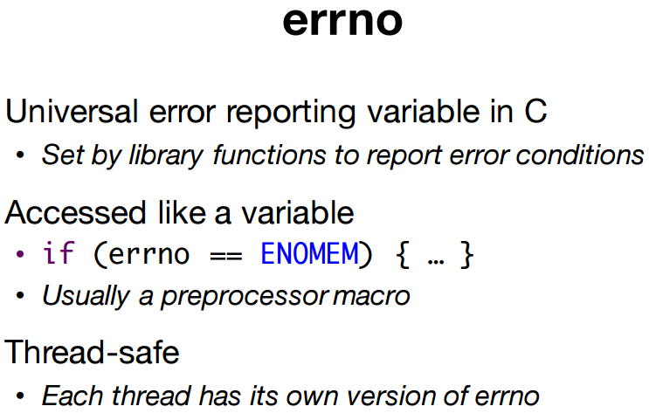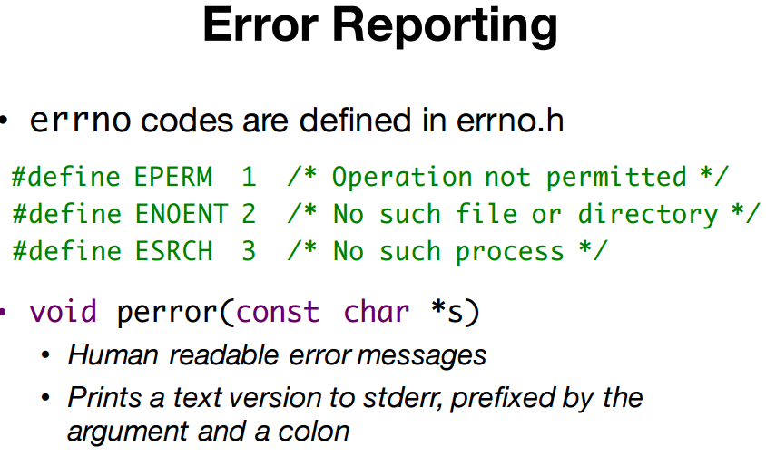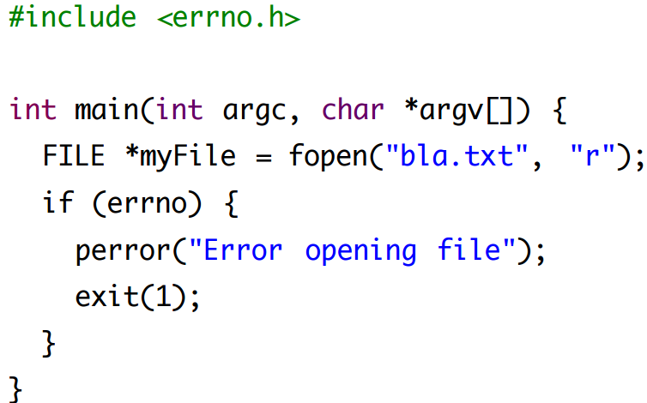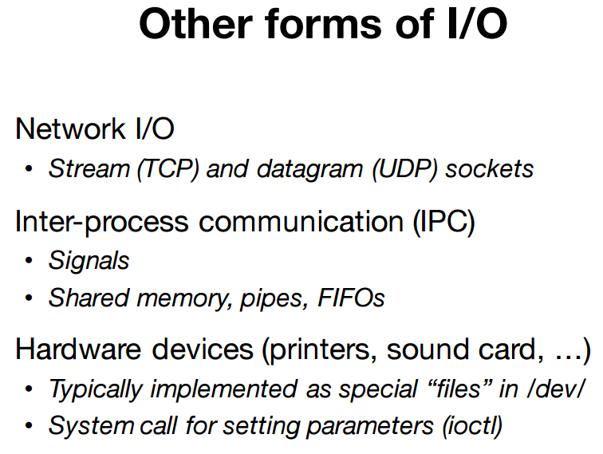**Multi-file Project**

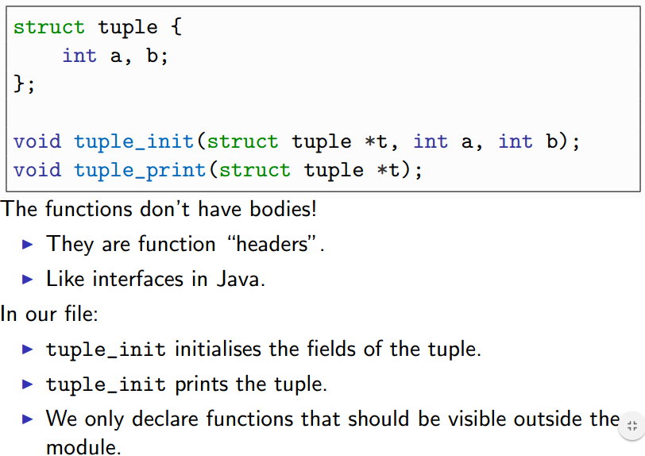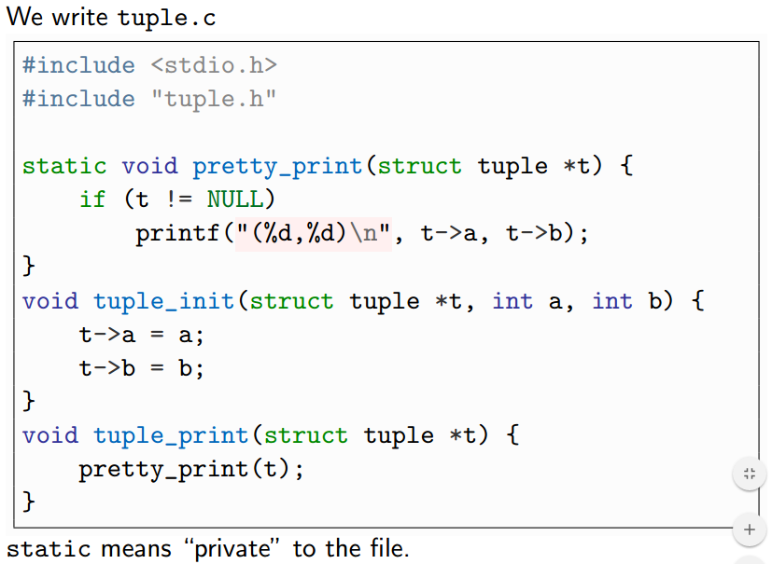

**Multiple inclusions- Problem**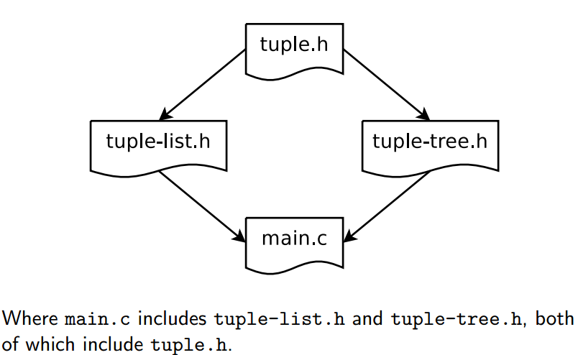

**Solution**

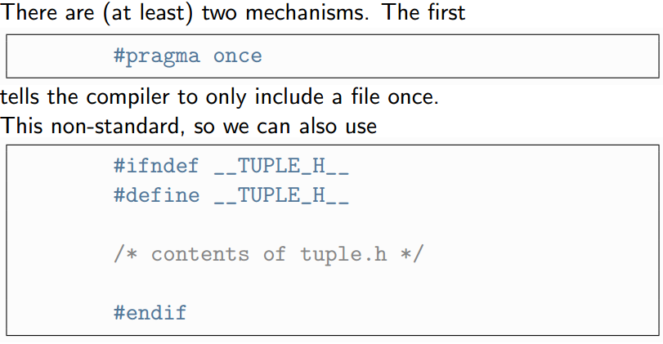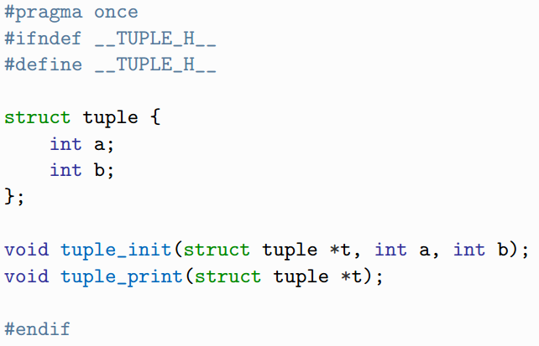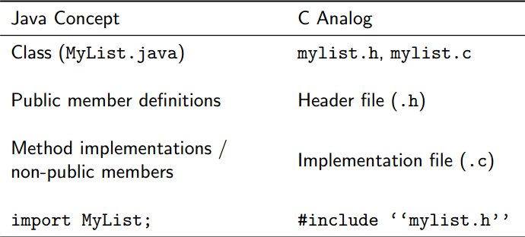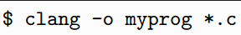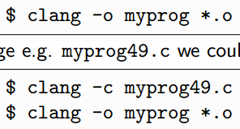

**Build Systems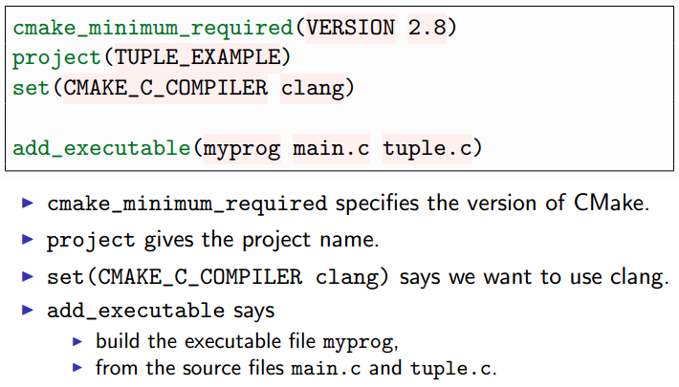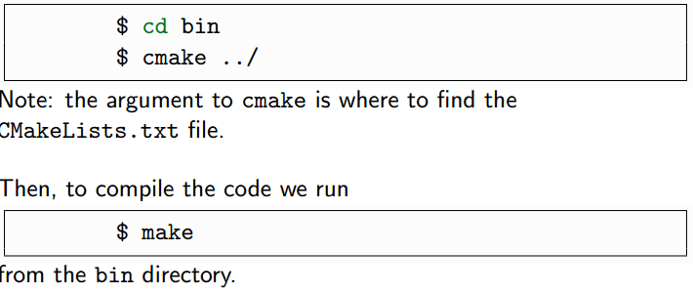**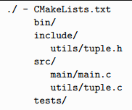

**Libraries**

Consists of: <object files (.o files)> <.h files>

Standard lib: in /usr/lib

Static lib: .a files (compiled in program)

* Not all programs will use

Dyn lib: .so files (dynamically linked)

* Used by a lot of programs
* Repeated codes

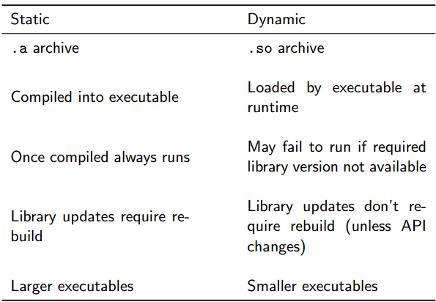

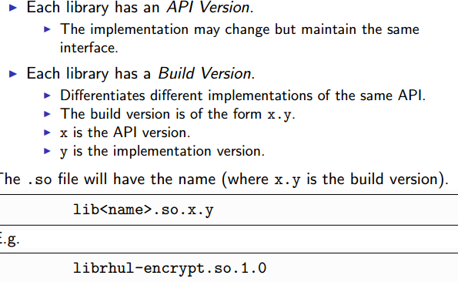

**Static**

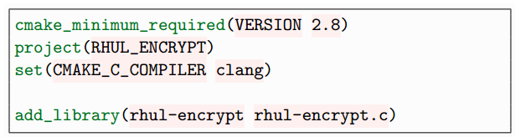

**main**

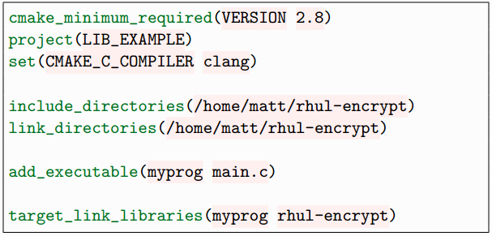

**Dynamic**

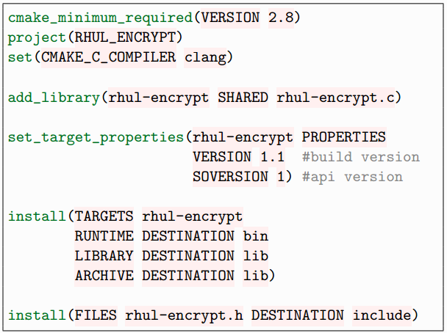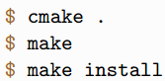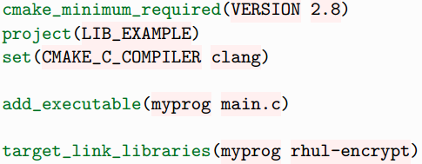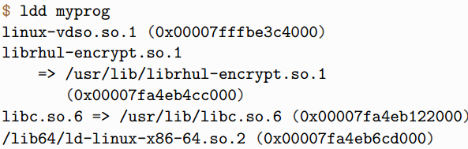**Processes and Threads**

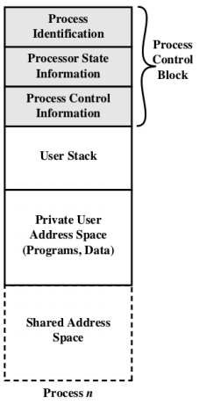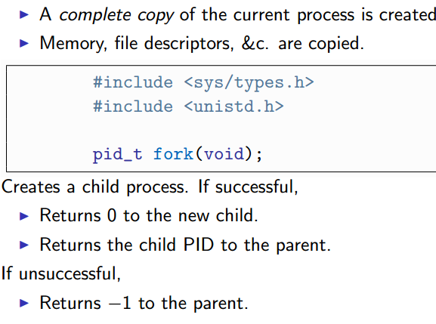

**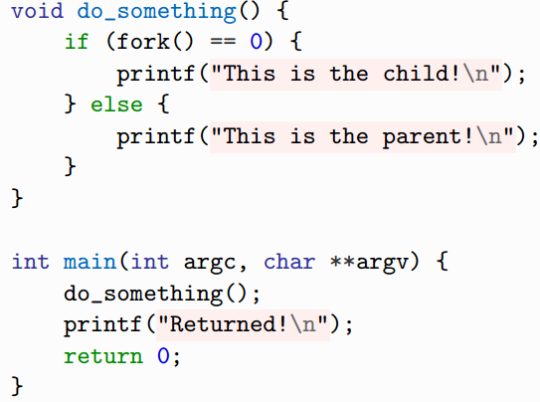  
parent, returned, child, returned**

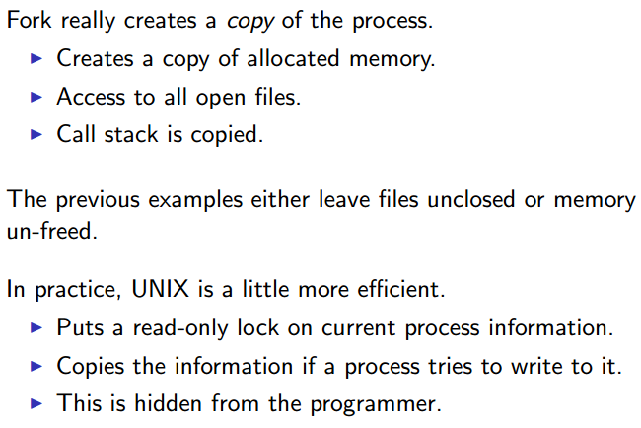

**EXIT**

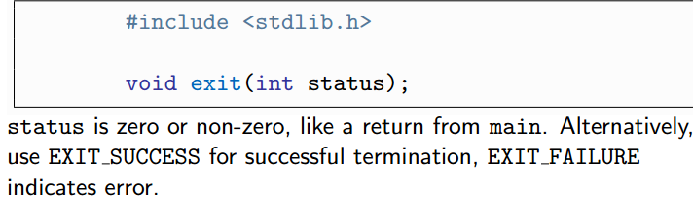

**WAIT**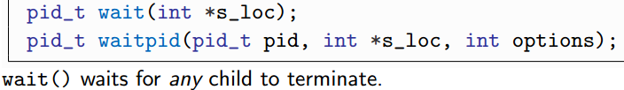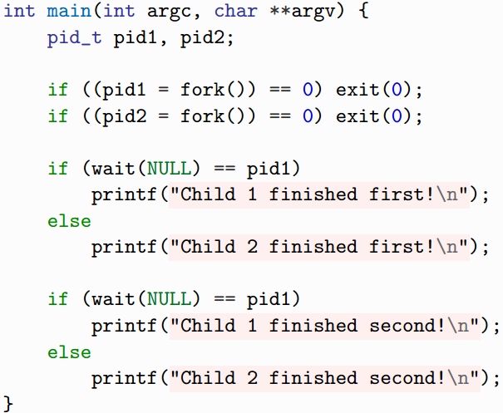

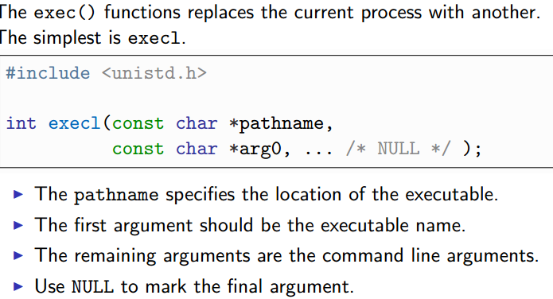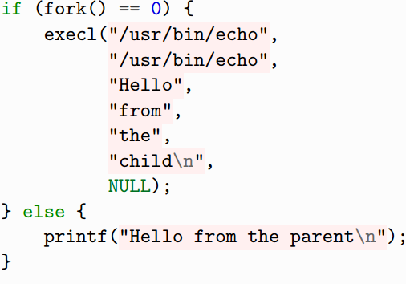

**SIGNALS**

* Notification sent to process  
  SIGKILL, SIGALARM, SIGTERM, SIGUSR1(no meaning)
* CTRL-C = SIGINT
* Signal.h
* Can ignore signal except (SIGTERM, SIGSTOP)
  + Signal handler function
  + 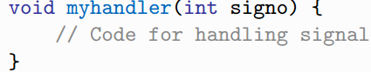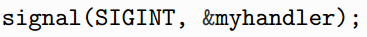

**To send signals**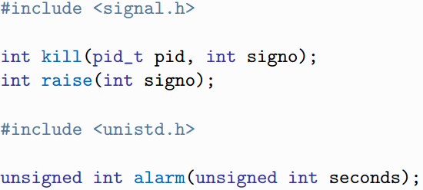

Kill = send signal  
raise = send signal to yourself  
alarm = sends SIGALARM after X seconds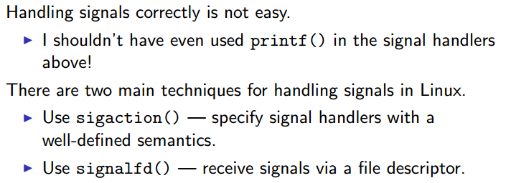

**Sending Data in Channel**

Channels

* Pipes (1 way, forked)
* FIFOs (1 way, separate processes)
* Sockets (2 ways, process on diff machines)

File Descriptor

* IDs for files (stdin = 0, stdout = 1, stderr=2)

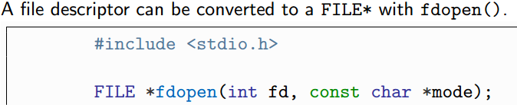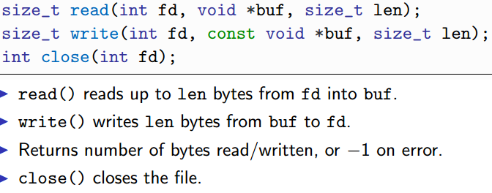

Pipe (between parent and child)

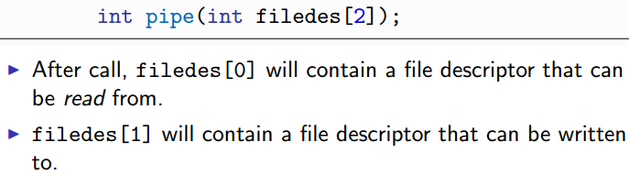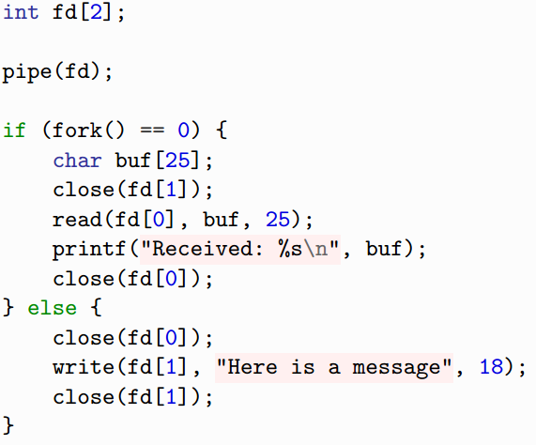

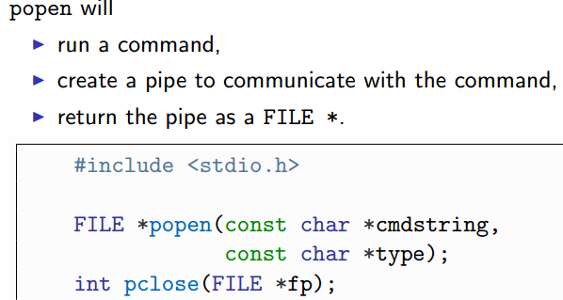type = r,w

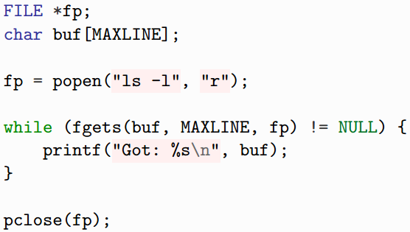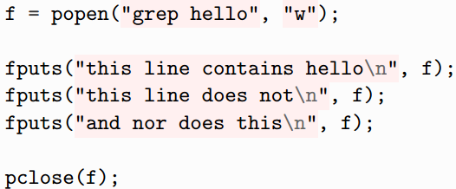

System Wide IPC

FIFO (similar to pipe, but can use unrelated process)

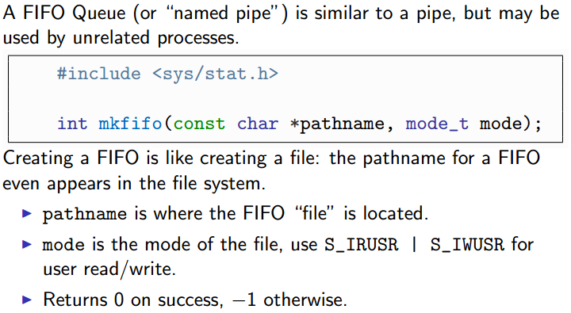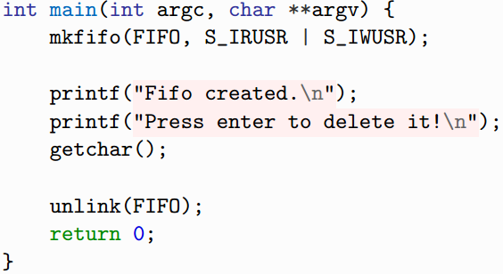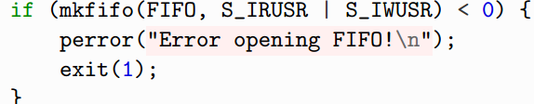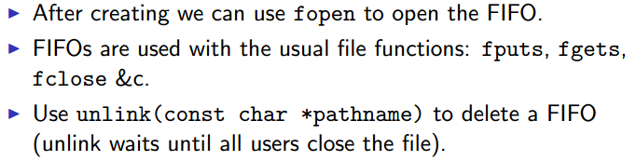

**Might be stuck in buffer (optimization), so use fflush(f) (to fflush it out)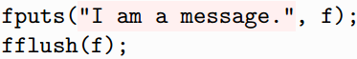S> 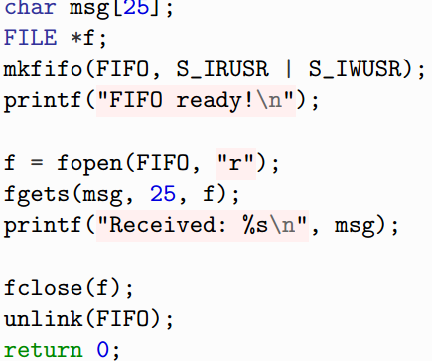c>**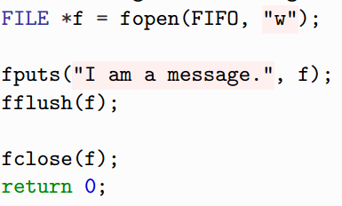

**Deadlock prevention**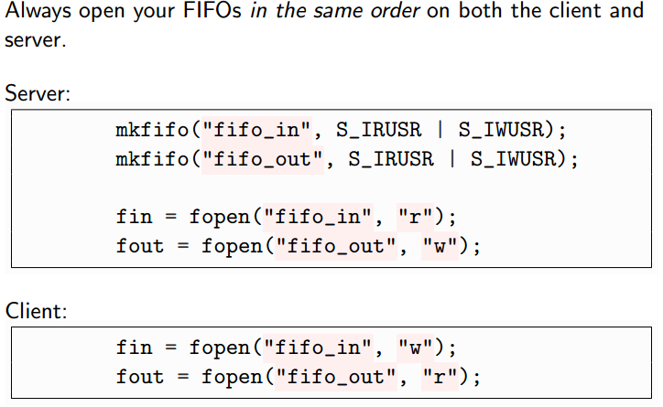

**Serialization**

To send complex data over channel

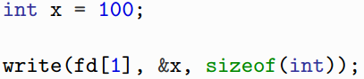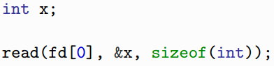

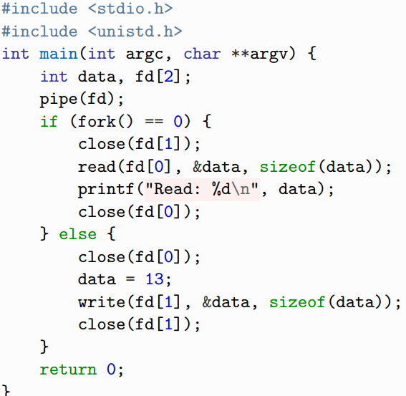

**For FIFO**

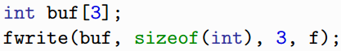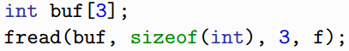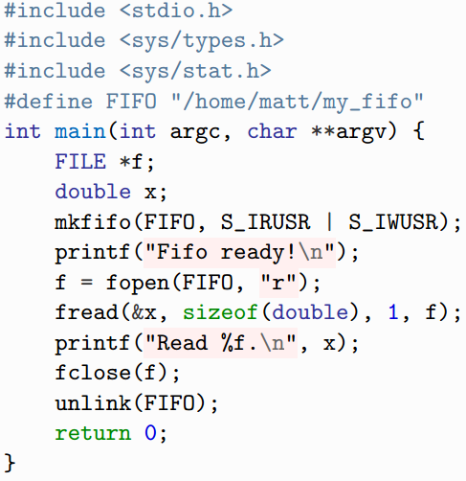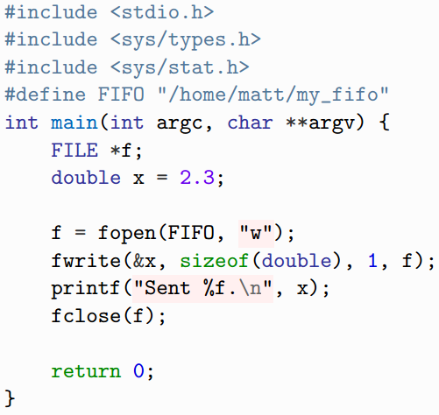

**Arrays**

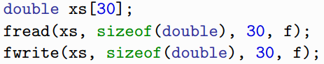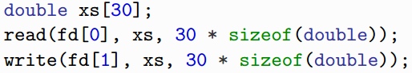

**Sending Struct (pack it)**

* Copy data into char buffer
* Send buffer in one call
* Read buffer, extract data

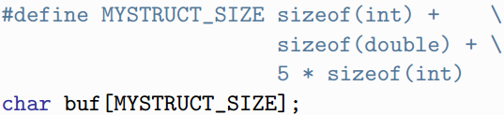

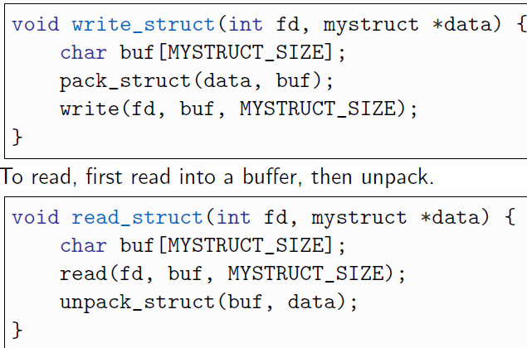

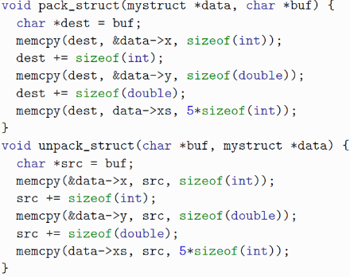

**SOCKETS**



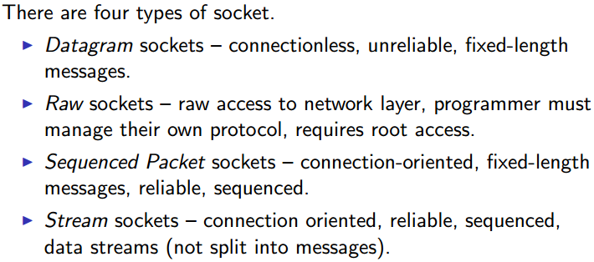

Data = fast, Raw = rare, Seq = reliable, Stream = var size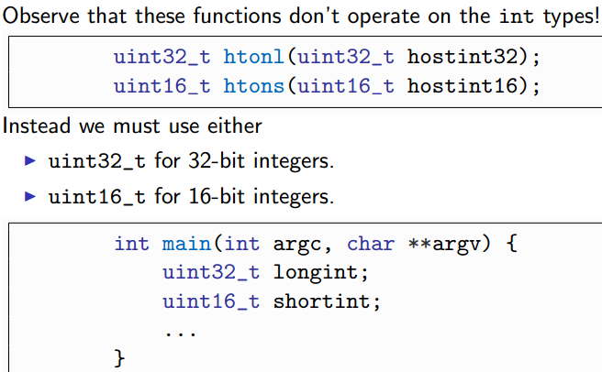

Connectionless Soc

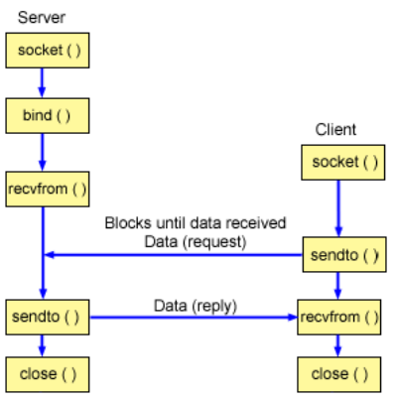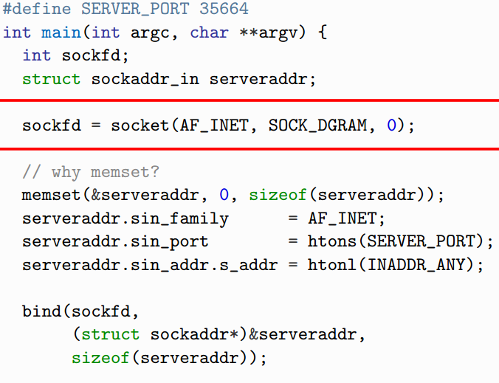

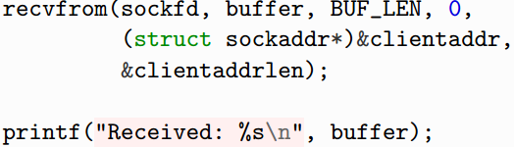

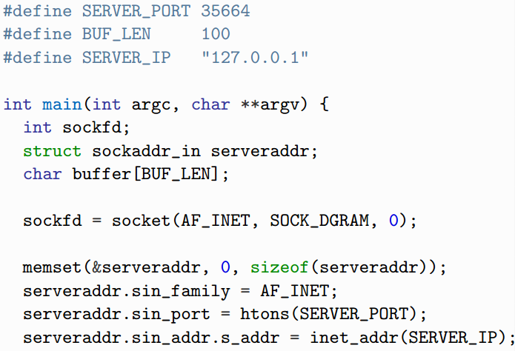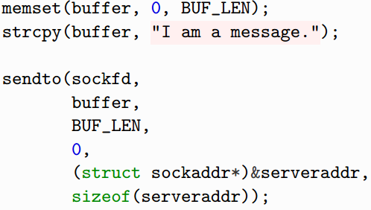



**Semaphore**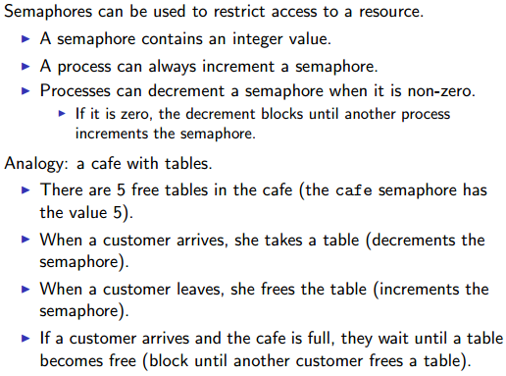

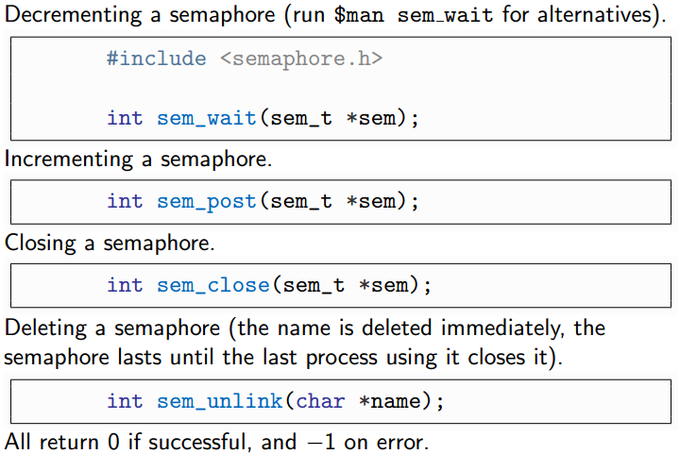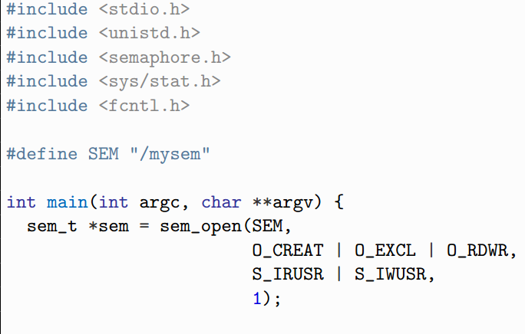

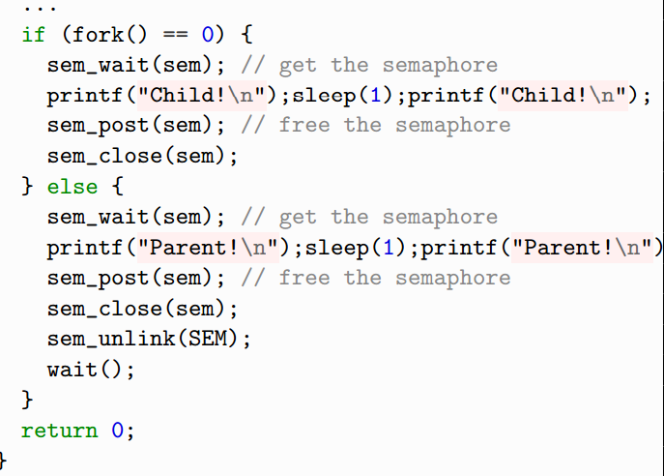

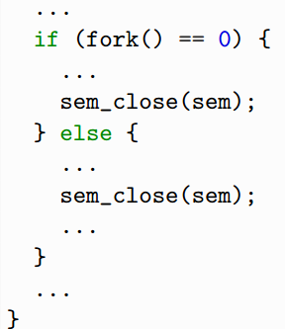

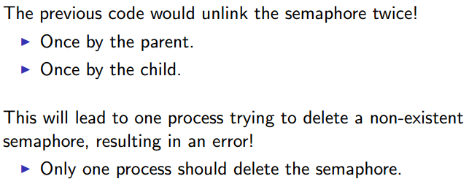



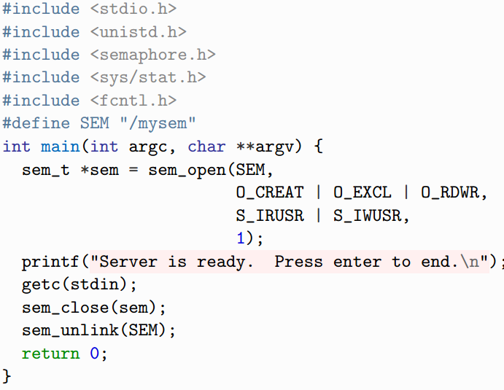

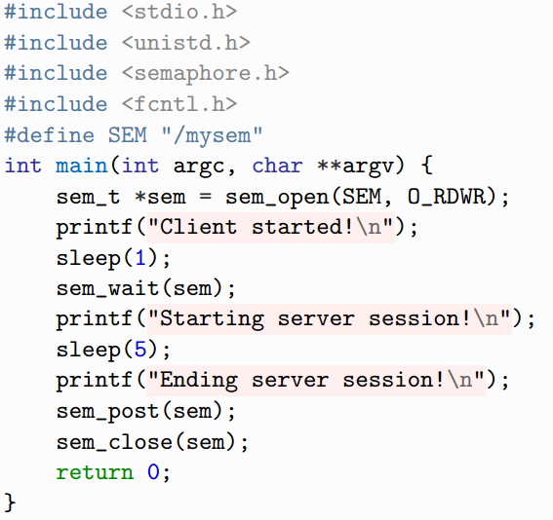

**Performance**

* Latency (time from submission of req to receipt)
* Throughput (no. of answers(obs) per second)
* Focus on observable perf (user’s notice)
* 80/20 rule (20% code takes up 80% runtime)

**Improve Perf**

* Turn off debug info
* Turn on compiler optimization
* Try another compiler
* Adapt perf req
* Get faster hardware
* Change high-level design
* Tune the code (if only you have to)

**Clang optimization**

* clang –O0 no optim
* clang –O1 some optim
* clang –O2 heavy optim, long compile
* clang –O3 aggr optim, but little over O2

**Accurate Measurements**

* Profiles (gprof)
  + Code instru, collect data, dump to file, interpret file
* Sampling-based profilers (oprofile)
  + Minimize interference with profiled program
  + 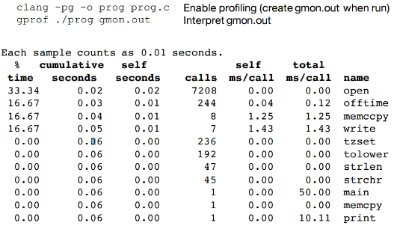

**Measure?**

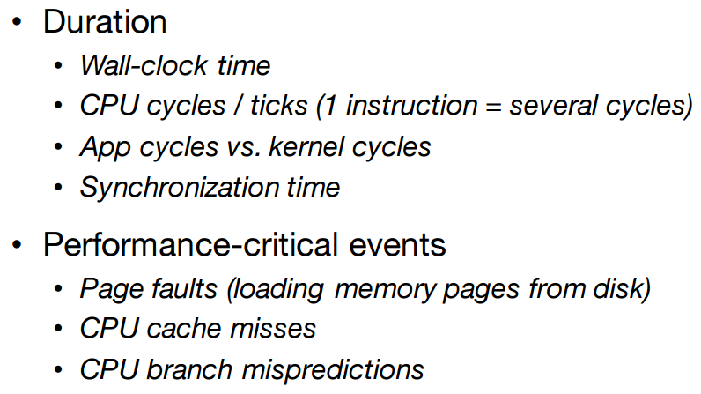

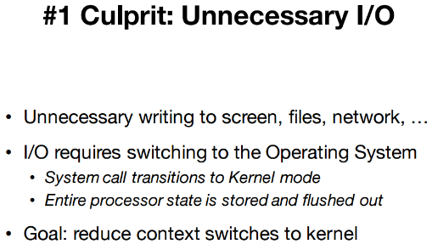

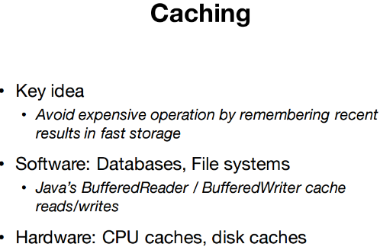

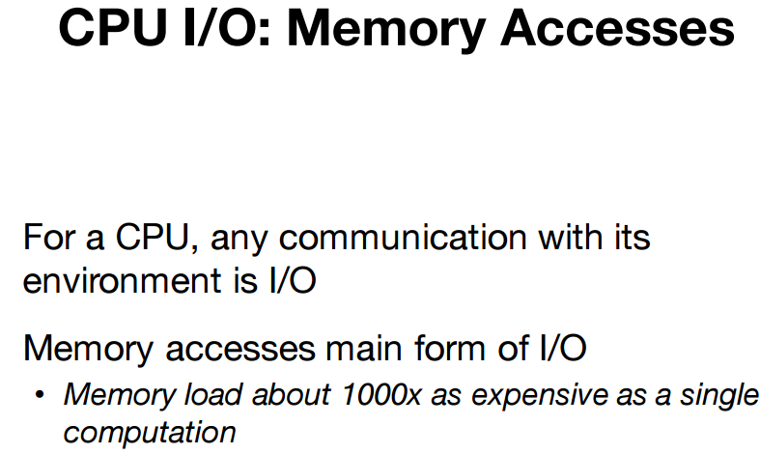

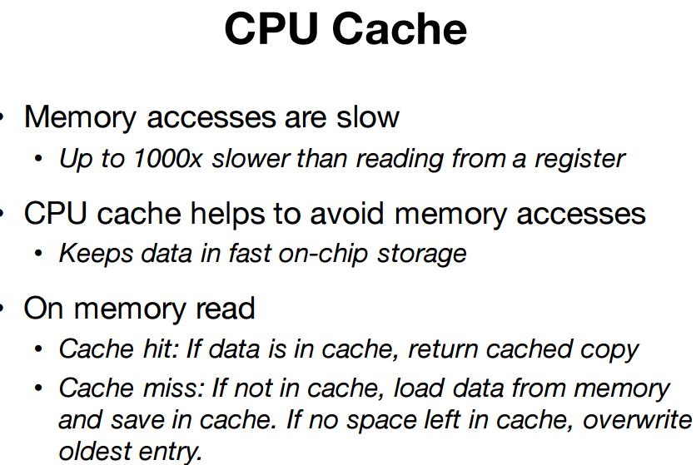

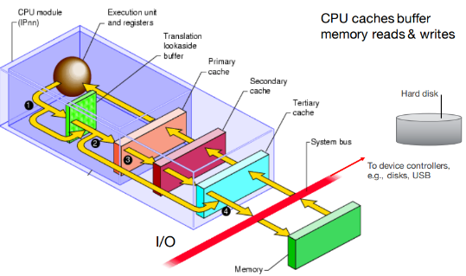

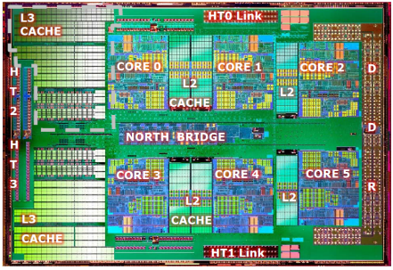

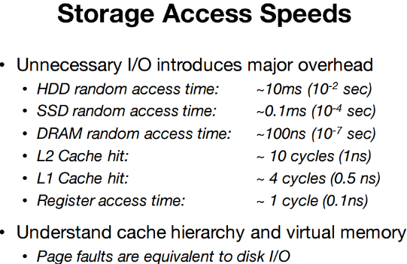

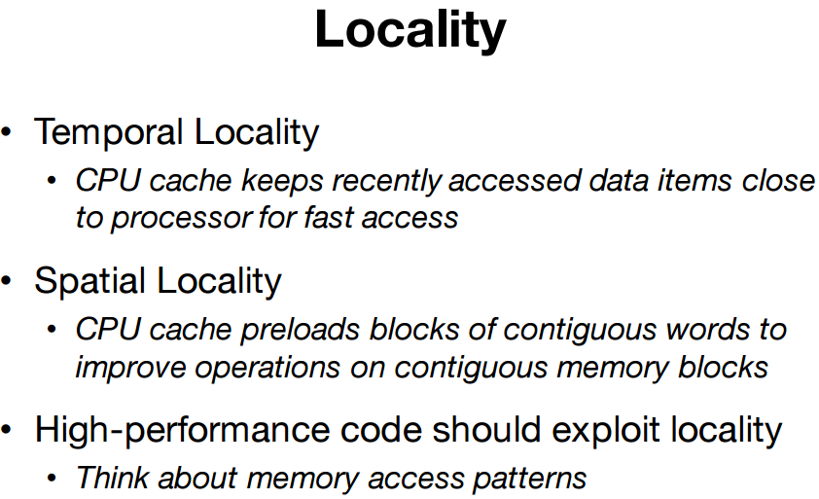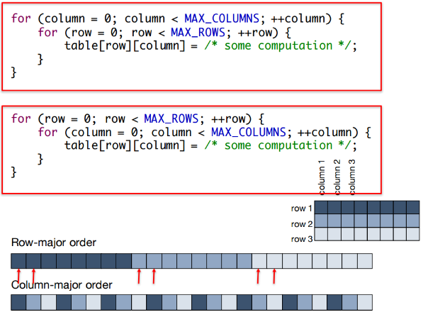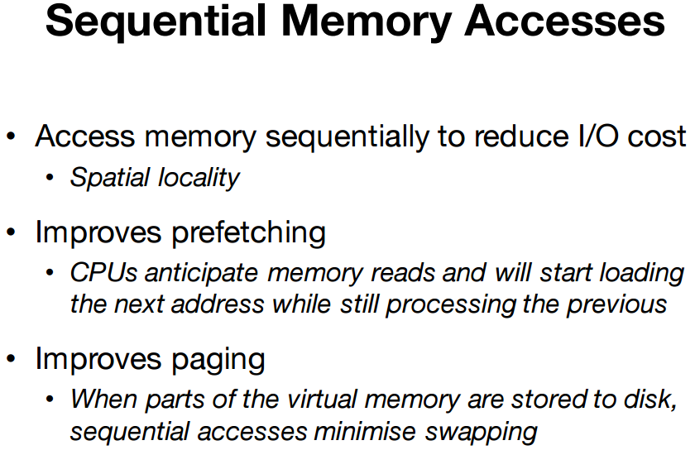

**Optimisation Process  
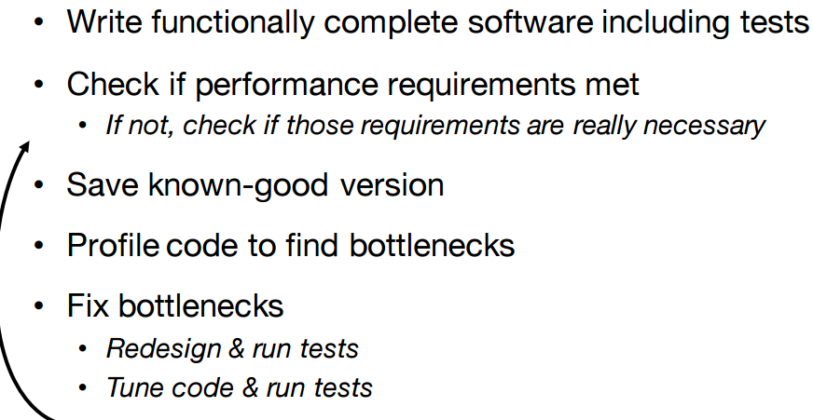**

**Don’t optimize prematurely.**

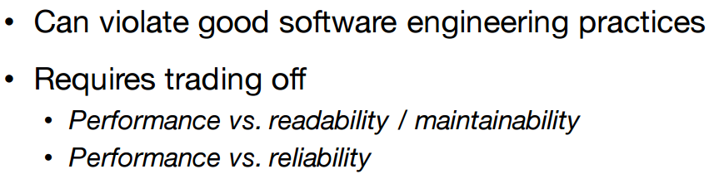

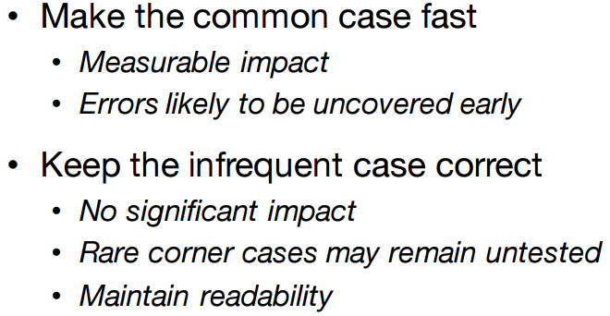

**I/O = main**

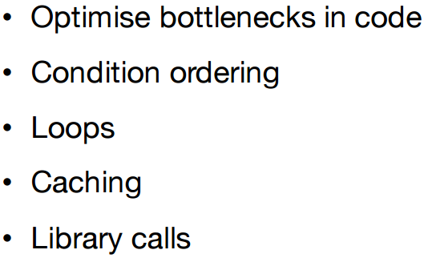

**Optimize Control Flow**

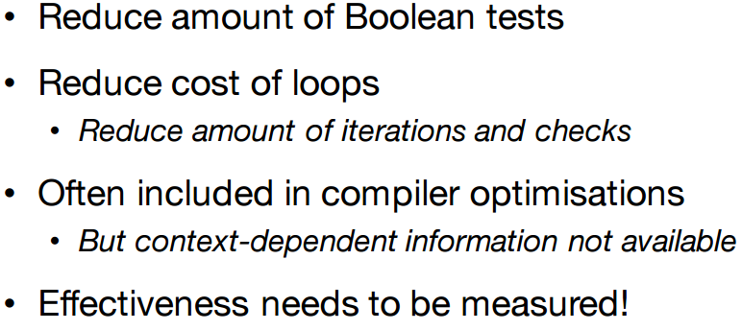

**Order Conditions**

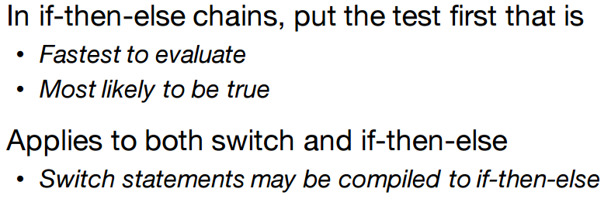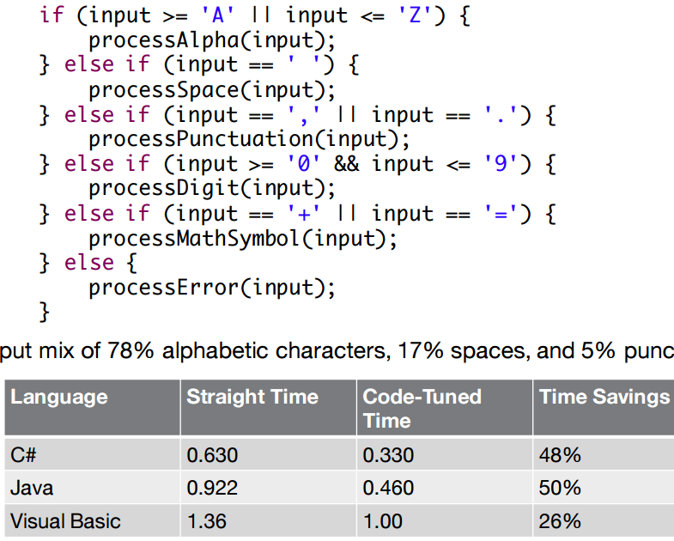

**Exit Early (when u know the ans)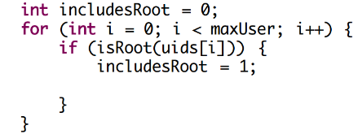**Break after finding root

**Memoisation (Cache calculated val)  
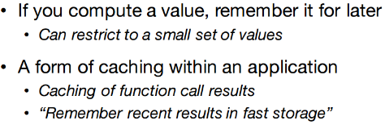**

**Know cost of lib calls**

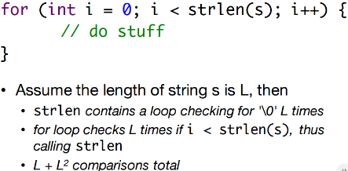

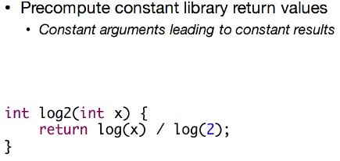

**Reduce accuracy**

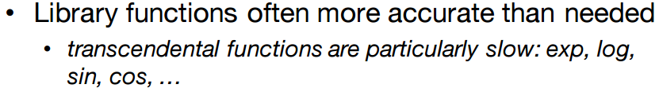

**Always measure**

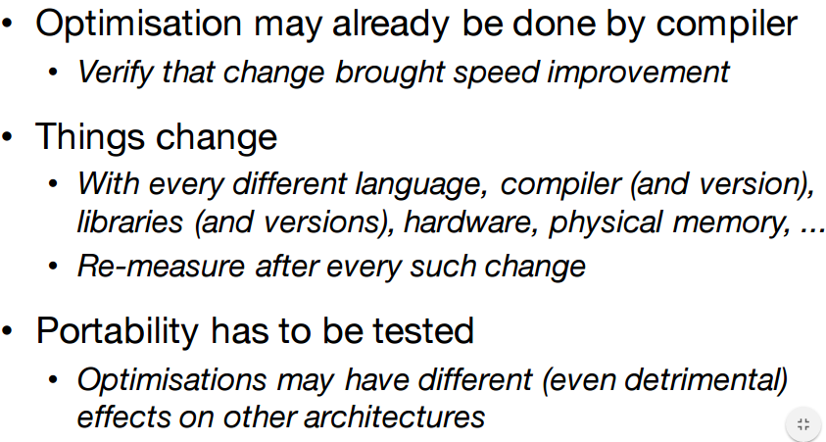

**Don’t optimize early**

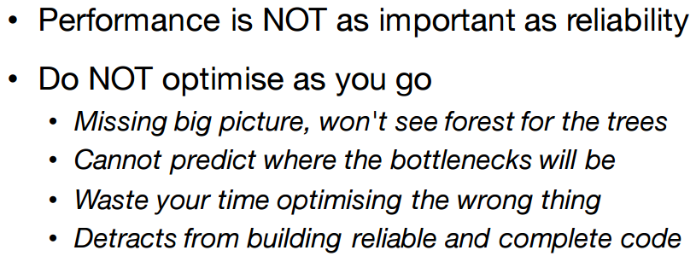

**First of all…**

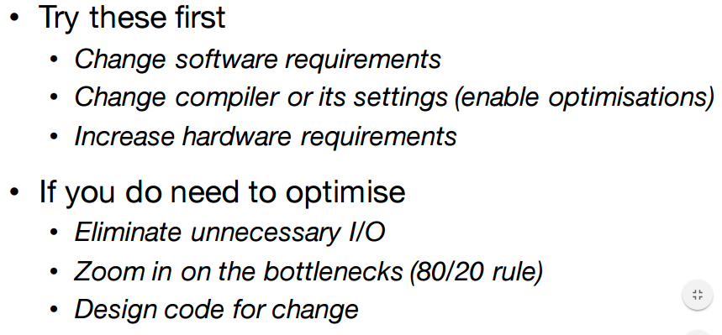

**Semaphores and Shared Memory**

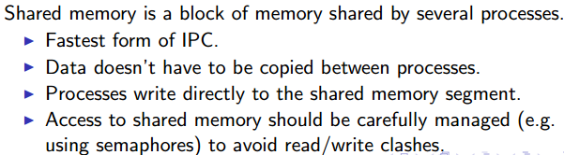

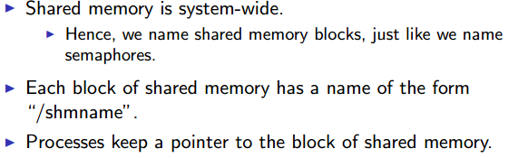

1. Open the shared memory
2. Sets the size
3. Gets a pointer to the memory
4. Free the memory
5. Close the memory (file)
6. Delete the memory (file)

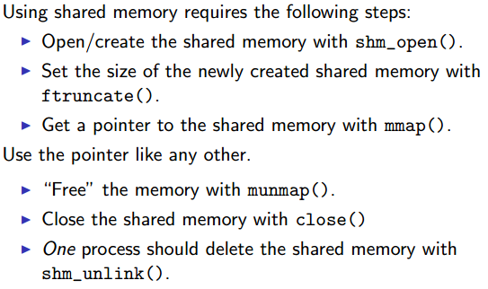

WRITER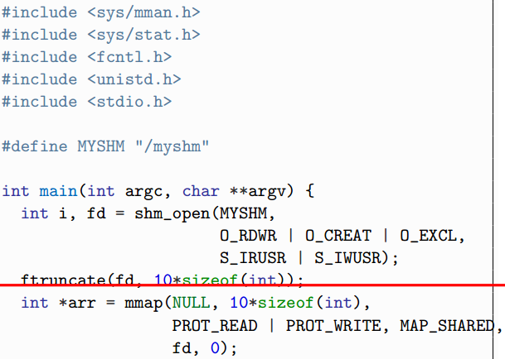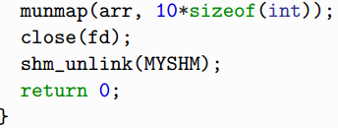

READER

